**Object Oriented Software Engineering**

**SP20-BSE-046**

**Lab-3**

**Lab Tasks:**

**1. Identify the Primary Actors form the list of Objects against your semester project**

**2. Pick only the Primary Actors along with the list of their Goals**

**3. Draw the Use Case Diagram of your semester project**

**Primary Actors of Project:-**

1. **Employee/Candidate**
2. **Admin**
3. **Employer**

**Goals of Primary Actors:-**

**Candidate:-**

* Login
* Upload Documents
* Upload Media Files
* Manage Profile
* Share Link to Profile
* Profile Settings

**Admin:-**

* Manage Registered Users
* Manage Skills data
* Promote Profiles
* Change username
* Share Link to Profile
* Manage Profile

**Employer:-**

* Login
* Review Profile
* Give Rating
* Hire Employee
* Contact Employee
* Give Feedback

**Use Case Diagram**

**Lab Tasks:**

**1. Write the two use cases form your semester project diagram in Brief Level format**

**2. Expand the brief level use cases into fully dressed format**

**Brief Level:-**

**1.Upload Document:-** A Candidate or user log ins to system and is provided with skills manage by admin and after completing profile User is given a Upload documents section, The user enters the location or path to the document and its format which are according to system needs and then system validates and shows the document on the profile of User.

**2.Generate Link:-** User Opens the profile menu and generate link button sends the system to link generation service and a random link is generated with URL and sharing option to other social media and copy to clipboard (Link is expired after 2 mins of generation).

**Fully Dressed :-**

**1.Upload Document(Usman Taufique)**

**Scope:-** Job Portal App

**Level:-** User Goal

**Primary Actor:-** Candidate

**Stakeholders and Interest:-**

**-**Admin:- wants the documents to approve the profile and level up.

-Employer:- Needs to see the work and achievement of candidate to hire.

-App:- Application requires the educational data in documents to approve the profile to register

**Preconditions:-** Browse for document. Candidate will be required to upload the document in order to maintain a public profile.

**Success Guaranteed(Post):**- After uploading of documents it will be published to the public server of portal which can be shared to people of companies.

**Main Success Scenario(Flow of events):-**

1. User Logins
2. System Greets with dashboard
3. User selects the documents section
4. Click Upload Button
5. Upload Dialog appears
6. Selects Docx Files
7. Upload file or can select multiples
8. File is Uploaded and shown in documents section

**Extensions(Alternative flows):-**

1. In case User selects the file of other format than .docx or pdf file the system rejects the file and file is not uploaded.
2. User has to publish the document after uploading to profile to make it visible to the person reviewing the file.
3. If User cancel the upload it goes back to the Document section.

**Special Requirements:-**

-Docx or pdf file Requires

-File size not be greater than 2mb

-Documents needed with educational information and work experiences in file forms.

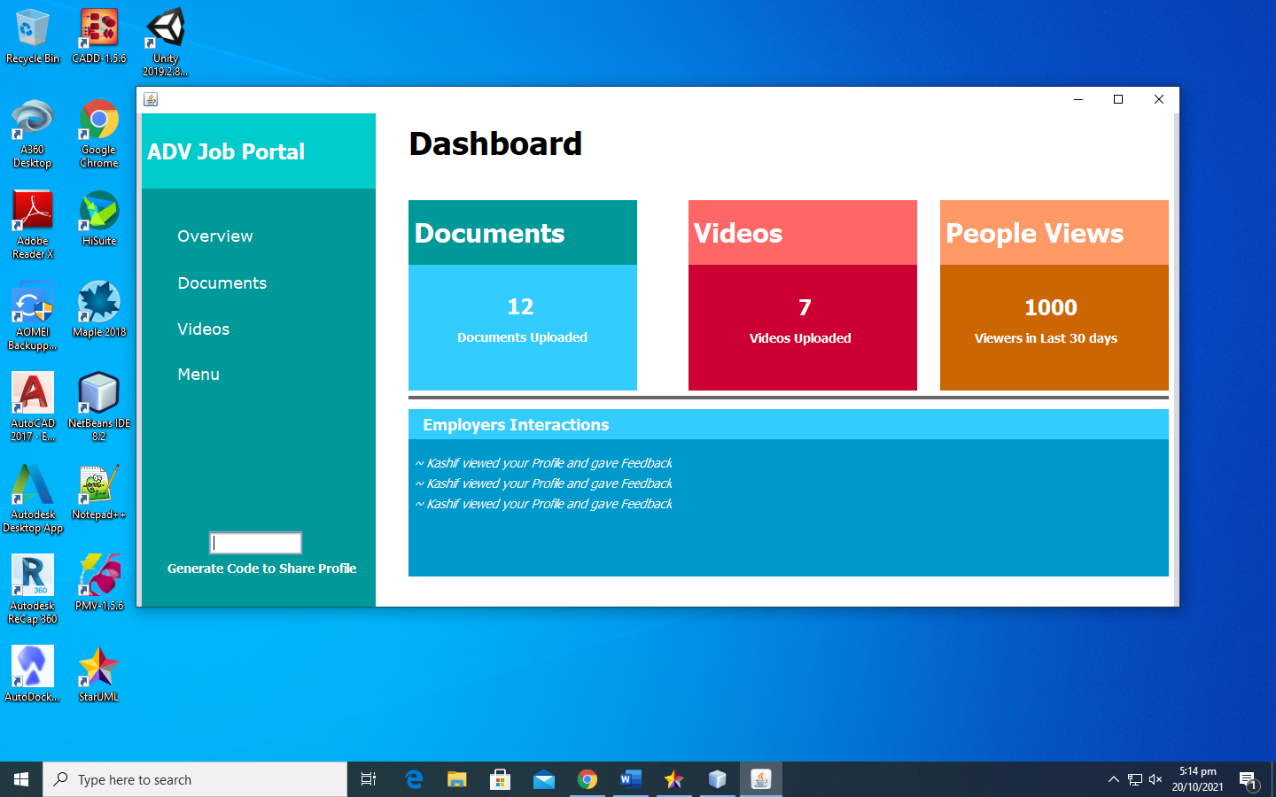

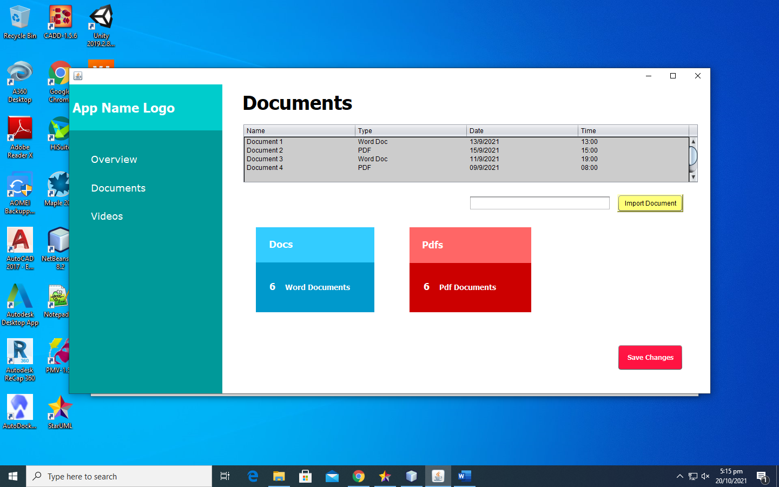

**2.Generate Share Code(Usman Taufique)**

**Scope:-Job Portal App**

**Level:- User Goal**

**Primary Actor:- Candidate**

**Stakeholders and interests:-**

-Candidate:- To share his work to public share code is needed

-Employer:- To hire someone and review profile the code is required to enter.

**Precondition:-** Someone want to see your data you just click on generate code and send generated link to person or company who wants .

**Success Guarantee(Post):**- After sending link to company or person

They are able to see your work experience and code is useful for 1 time at 1 device and automatically expire after using 1 time within 24 hours.

**Main Success Scenario(Flow of Events):-**

1. User logins
2. User Clicks the share code button on dashboard.
3. Code is generated as password to cloud
4. Code copy option is visible
5. User sends the Code to employer
6. Employer can use the Code to review profile or Hire.
7. Code is expired after 2 mins of generation.

**Extensions(Alternative Flow):-**

1. Code not opened in 2 mins it expires and shows nothing on click.
2. Code cannot be opened more than one time for one employer.
3. If Employer does not open link it expires
4. New link is generated and old is destroyed if user generates a new one.

**Special Requirements:-**

-Code must be generated and then copied too in 2 mins.

-Copied Code should be a small URL.

-Two generated Code cannot be same.

-Employer gets only viewing access to profile by Code

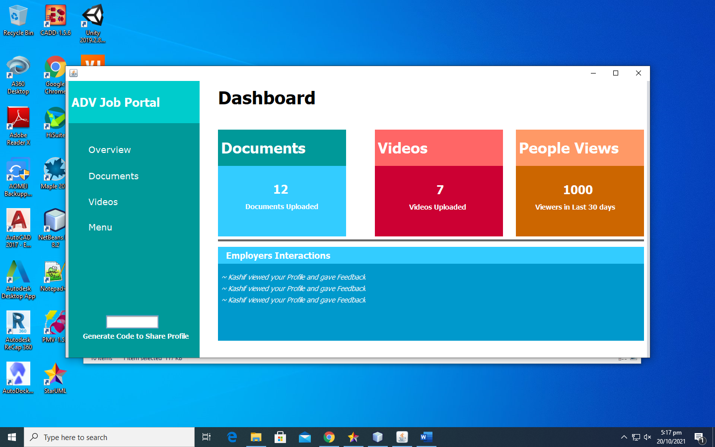

**3.Upload Videos(Media):**

**Scope:-Job Portal App**

**Level:- User Goal**

**Primary Actor:- Candidate**

**Stakeholders and interests:-**

-Candidate:- To share links to work videos on cloud storage or streaming platform.

-Employer:- Making a good review of employers work the video is required to post good feedback.

**Precondition:-** Candidate login to the portal and makes his profile more unique and attracting by giving links to the videos of work he/she has done or experienced.

**Success Guarantee(Post):**- When Candidate uploads or posts the link to video on his profile it is visible to employer to whom he/she shares code with and can view his/her videos on site or cloud.

**Main Success Scenario(Flow of Events):-**

User logins

User Clicks the Videos Section button on dashboard.

Videos list with links appears on App.

Links are clickable and clicked by user to review.

Candidate can upload new ones with upload button at bottom.

Clicking upload button brings up the dialog box with text to enter link to video.

After saving the link is available on Videos section of Dashboard.

**Special Requirements:-**

-Video link must be a link to only video.

-Copied Link should be a small URL.

-Cannot upload Videos Directly to App.

-Employer gets only viewing access to videos.

**4.View Profile:**

**Scope:-Job Portal App**

**Level:- User Goal**

**Primary Actor:- Employer**

**Stakeholders and interests:-**

-Candidate:- To make custom changes to profile as putting more information and details about experiences and education to make him/her more unique in list.

-Employer:- Wants to hire someone for work and company then wants to search or view profile or that candidate on app.

**Precondition:-** Candidate sign ups for app and choses the category of profile he wants to develop on app for work and market.

**Success Guarantee(Post):**- Candidate sign ups and login to app and then profile editing section is shown to edit name birth date and profile image for specifying the credits and information about him/her and employer searches for profile by code shared with him and has viewing access to profile

**Main Success Scenario(Flow of Events):-**

User sign ups

User Makes a Custom profile with need information.

Custom Profile with unique code is registered to app.

Code is shared to employer and he logins.

Employer after typing code clicks view profile.

The manage profile of user is displayed with relevant information to Employer.

**Special Requirements:-**

-Profile must be completed before sharing.

-Profile can only be shared when information is fully registered.

-User cannot make two profiles with same account.

-Employer can only view the profile.